**AR Enterprise**

**Vertical 1**

**1st Part**

**Challenge 1**: Pending Orders (Challenge Done by Nilesh)

To recover all pending orders. Pop up notifications and report of pending orders ++

**Object: -** Order

**Fields**: - 1) Order Start Date

2) Order End Date

3) Status

**Example: -**

* If Order Start Date is **2 July 2022** & Order End Date is **4 July 2022** that time Status Automatically Change that is Pending, we get one Notification That is your order is pending.
* Today’s date is less than order end date then you have to give one notification that is your order is pending.
* Today’s date is Greater than order end date then you Don’t have to get any notification.

**Steps: -**

* Go to Orders Tab
* Select New
* Select Account Name, Order Start Date, Order End date, Status, Contract Number
* Click Save

Note: Go to the Bell Icon and you can see notification

**Challenge 3**: Pending Items (Challenge Done by Nilesh)

If someone orders 100 items. We only delivered 80 items at that moment. 20 Items are remaining. Pending List item should be show for the particular person/party

**Object: -** Order Product

**Fields**: - 1) Quantity

2) Delivery Items

3) Remaining Item

**Example: -**

- If Stock Is Less than Quantity then shows the Remaining Item

- If Stock is Greater than Quantity then Remaining Item is 0

**Steps: -**

* Go To Order Tab
* Related
* Add Product
* Select Products
* Add Quantity
* Save

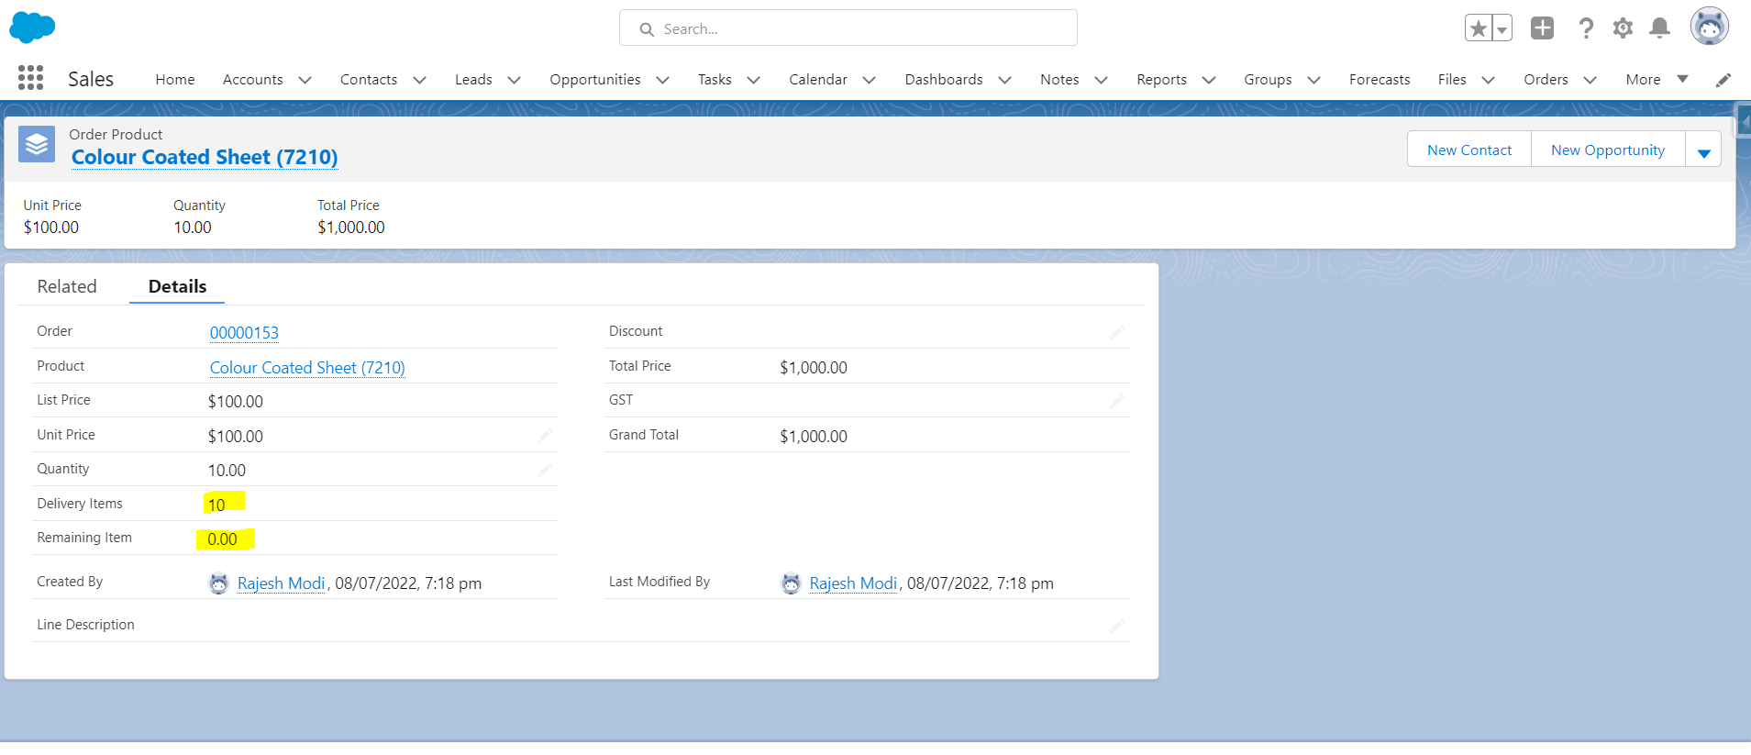

**Report: -**

* Report is generated for showing Remaining Item. Report will be sent to the Owner Mail Id.
* Report will daily show at 11 AM

**Challenge 4**: Payment pending notification (Challenge Done by Nilesh)

After 12 to 15 days (Also, report can show all pending payments)

**Object: -** Order

**Fields**: - 1) Total Order Amount

2) Advance Amount

3) Remaining Amount

**Example: -**

Owner will receive mail, that How much is the customer's payment balance and his name

Note: As well as we can check Report for which customer's payment balance and his name.

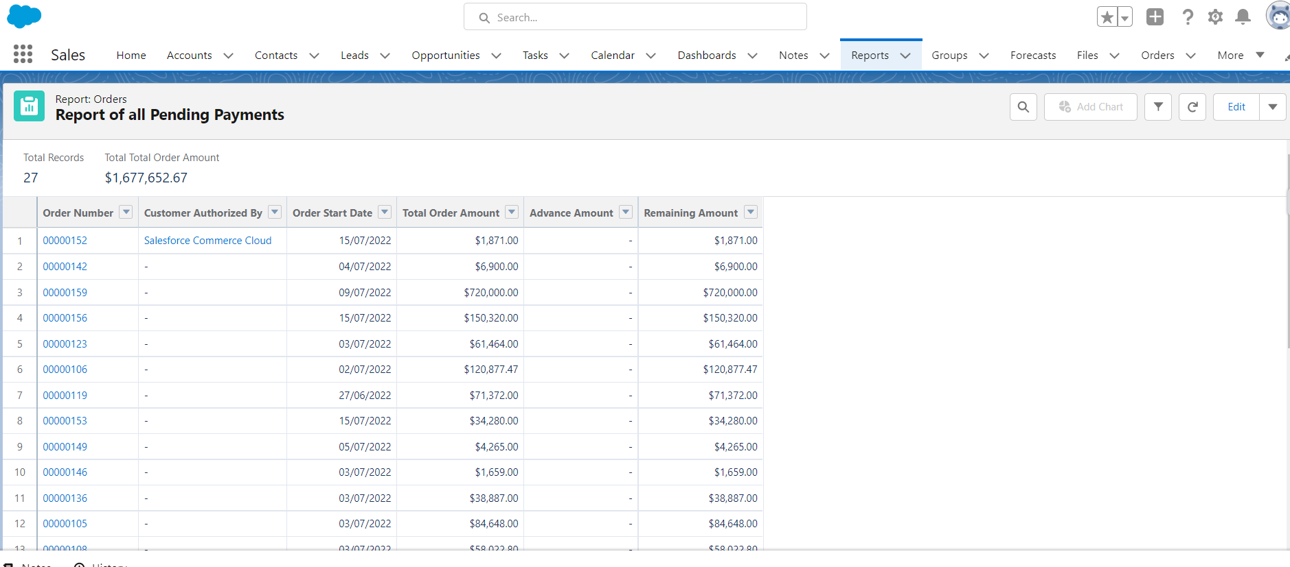

**Challenge 5**: Stock challenge(operational) (Challenge Done by Nazia)

Notification for re-stock to the particular buffer stock.

**Object: -** Product, order product

**Fields**: - 1) Stock Quantity

2) Quantity

3) Stock Status

**Example: -**

* If Stock is 100 and we have order 10 Products then it will be subtracted.
* If Stock is 90 and Customer change quantity and he has order only 5 Items so that 5 remaining items will go back and add to the Product, now product stock quantity is 95.
* If any product is deleted from order product, then that remaining 5 also will go and add in the product object and show in the stock quantity field.
* If Stock Quantity is greater than 100 then Stock Status is automatically change that is Stock Available.
* If Stock Quantity is Less than 100 -50 then Stock Status is automatically change that is Re-Stock.
* If Stock Quantity is Less than 50 then Stock Status is automatically change that is Out of Stock.

**Steps: -**

* Go to order object
* New
* Go to Related
* Add Order Product
* Select Products then add quantity (any number)
* Save
* Click on Selected Product
* check the stock quantity values

**Notification:** -

whenever stock quantity is less than 100 then current user will get notification to list of the product

**2nd Part** (Challenge Done by Sneha & Nilesh)

**Product & Price**: Set up products along with prices and discount accordingly

Challenge 1: Order should be accepted on the basis of price which we have mentioned in the Salesforce. If someone try to order differently, the error should generate and not allow to save order.

**Object: -** Order Product

**Fields**: - 1) Quantity

2) Unit Price

3) Discount

4) Total Price

5) GST

6) Grand Total

**Example: -**

- Quantity & Unit Price Calculation Shows in Total Price

- Total Price & Discount Calculation Shows in Grand Total

- Total Price & GST Calculation Shows in Grand Total

Whenever Dealer Wants to add discount & GST in Total Price then all Calculation Shows in Grand Total

**Steps: -**

* Go To Order Tab
* Create New Order
* Go to Related Tab
* Click on Add Product
* Select Product Whatever You Want
* Add Quantity in All Selected Product
* Click on Click on Selected Product
* Add Quantity & Unit Price
* Click Save

After that Edit This record and whatever you want add Discount & GST Then You can see the All calculations.

**Quotation management** (Challenge Done by Sneha)

**Steps: -**

* Go to Opportunity
* Select Opportunity Record (that you have select in order)
* Go to Related
* Add Products (whatever you selected in order product)
* Go to Quote tab
* Click on New Quote
* Create New Quote
* Select Order Number
* Select Contact name
* Save
* Open this Quote Record
* Click on Button Section

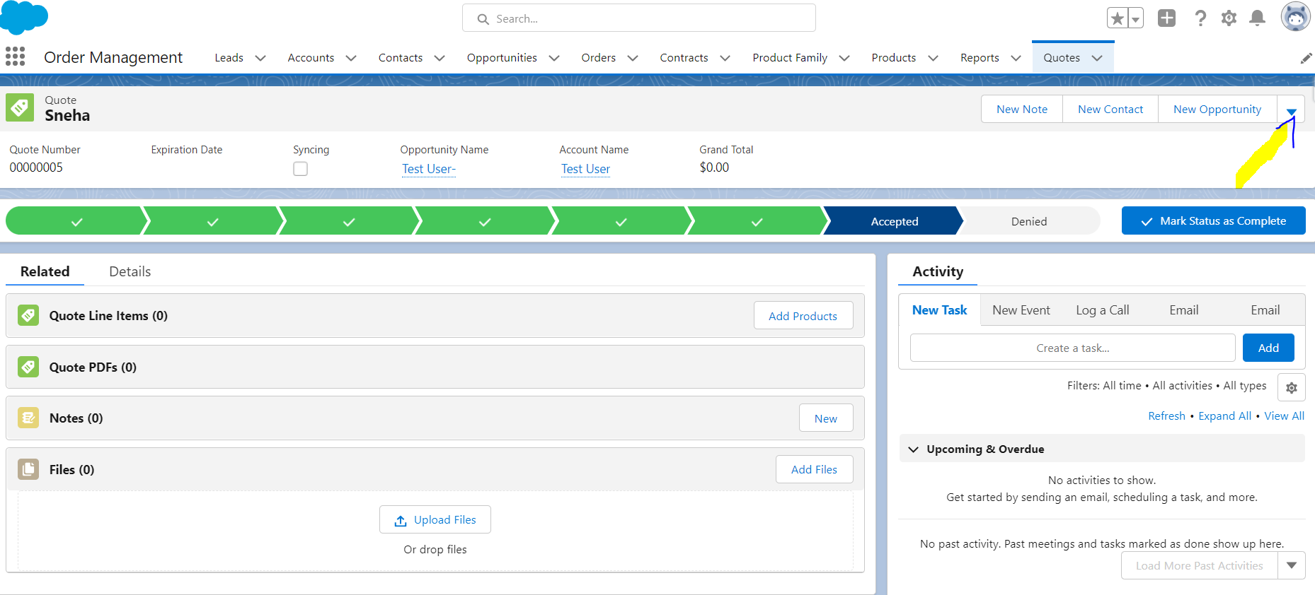

* Click on Create Pdf button
* Save and Email Quote
* Compose Email
* Send

If we provide customer email Id in that time whenever we created Lead then this customer received All Products detail by this pdf .

User: -

